User Manual:: Pro-JJG_Pharma web application

Navigation Bar:

* Access most pages here
* Profile, Purchases and Prescription require you to login first

Login Page (Landing Page)

A. Login, Enter account username and password to login

B. Access register page

Register page

A. Create account, enter account details and create account

Profile Page

- Only accessible after account creation

A. View Profile details

B. Logout of account

C. Update account info, re-enter account info and update all fields

D. Delete account (Cannot be undone)

Medicine Page

A. View medicines

B. Click “purchase” to purchase medicine, purchases can be viewed in the “purchases” page

Purchases Page

A. View your past purchases here

Prescription Page

A. View prescriptions here

B. Enter your prescription here to create a new prescription

C. Edit prescription, will show “edit” form with prescription data

D. Delete prescription

**Login Page**

**Profile Page**

**A**

**A**

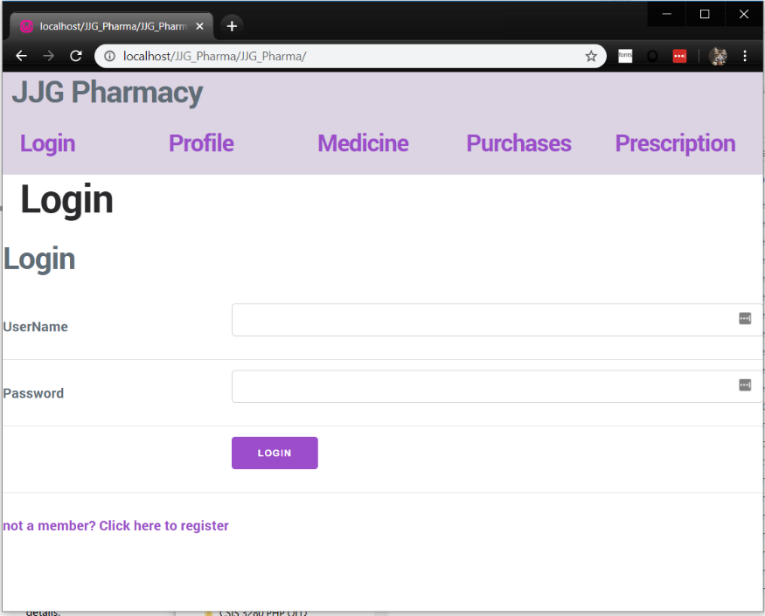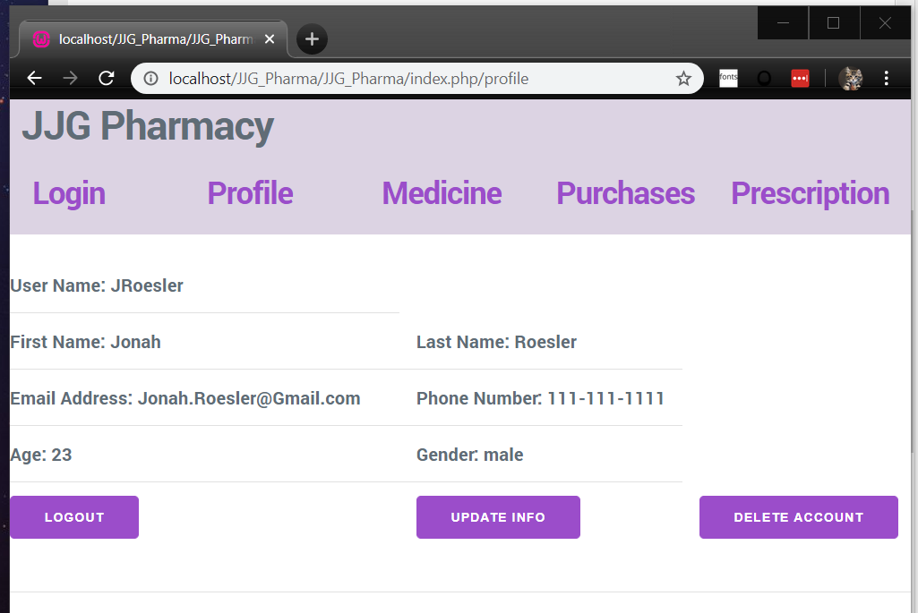

**D**

**C**

**A**

**B**

**B**

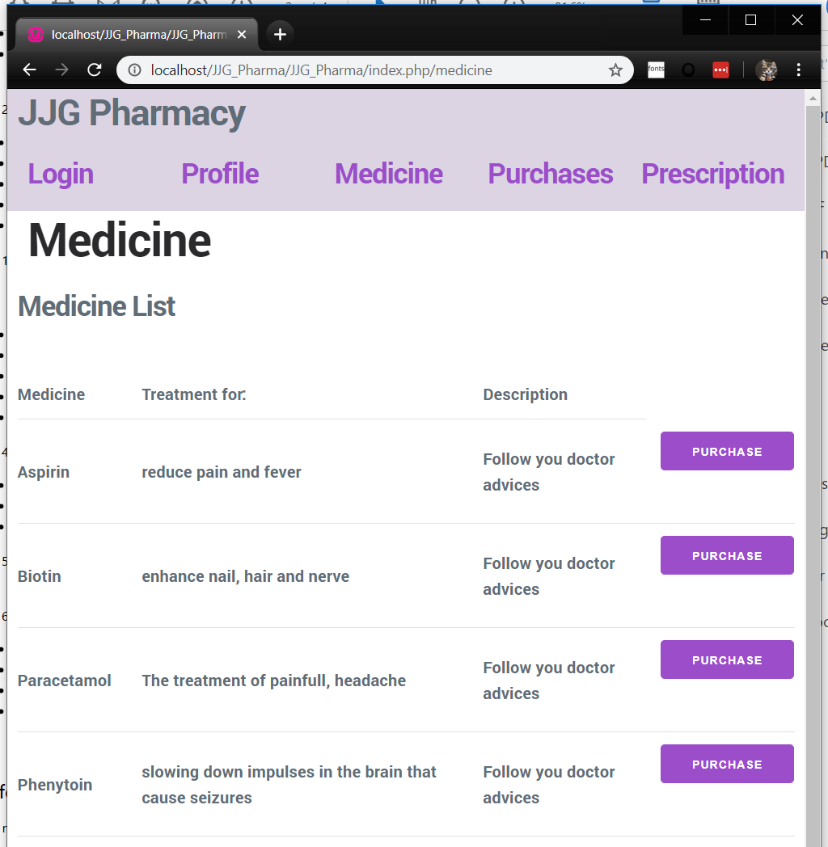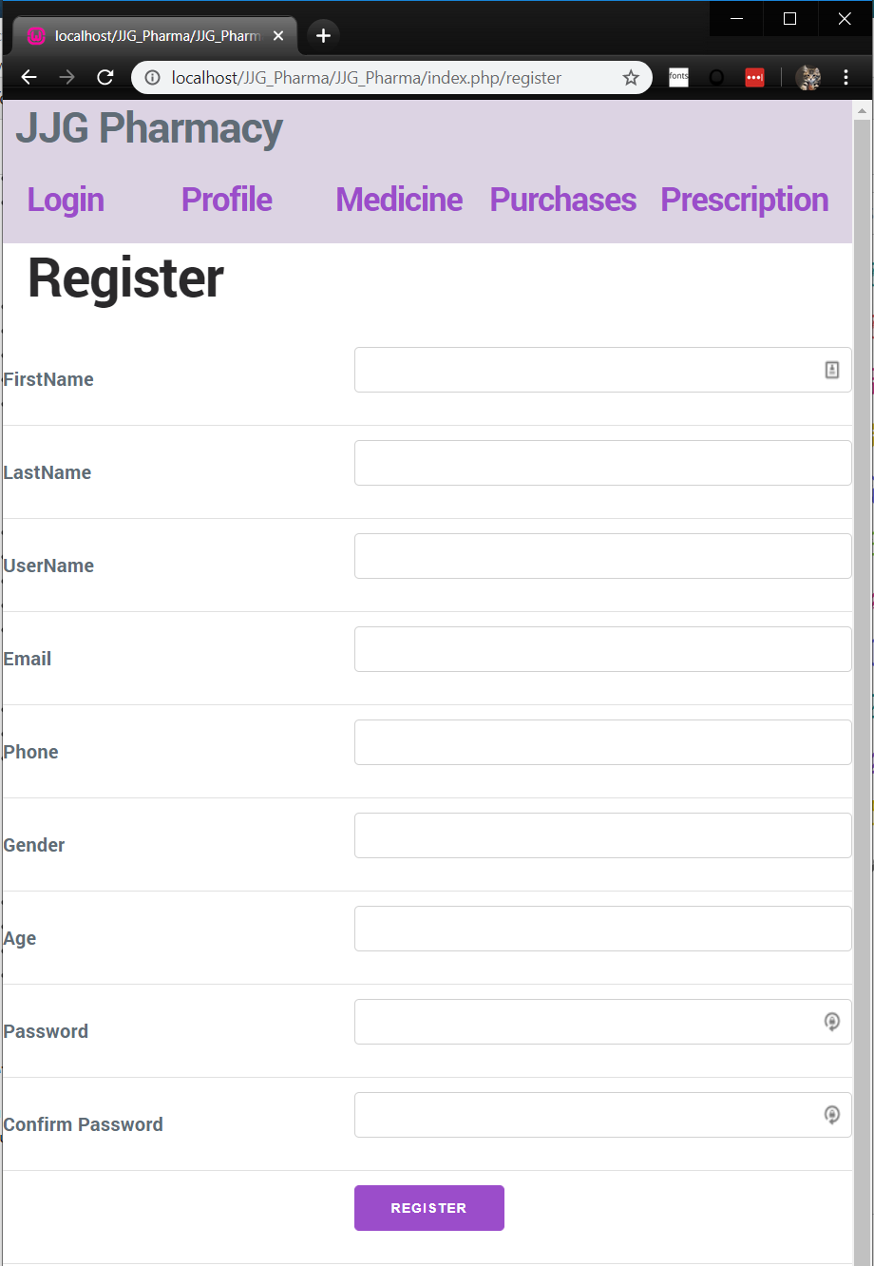

**Medicine Page**

**Register Page**

**A**

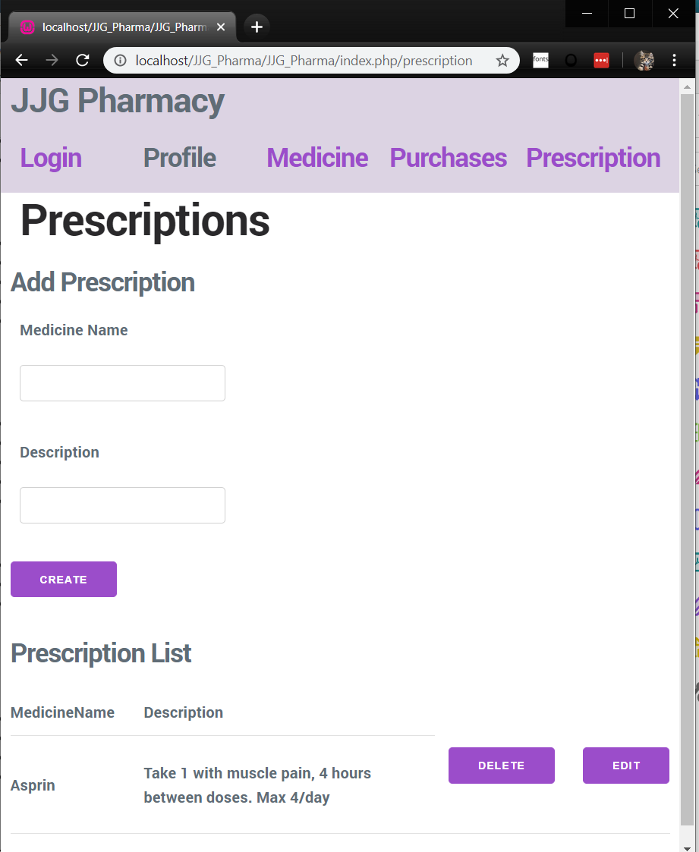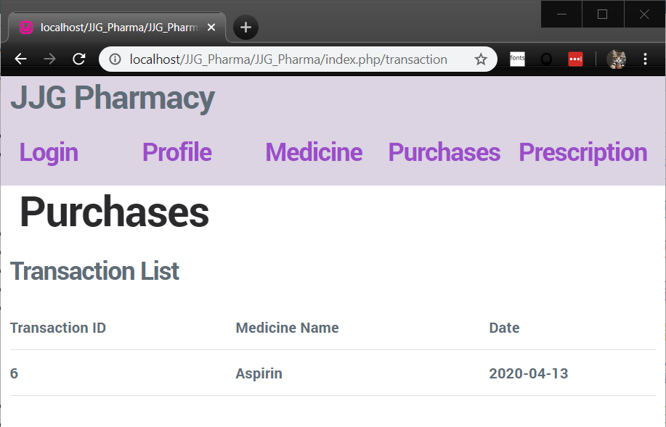

**A**

**B**

**A**

**C**

**D**

**B**

**A**

**Prescription Page**

**Purchases Page**